**Sub-skills of Speaking**

**Vocabulary:**

Need to know the right words to pick for right purposes. Be careful about diction (choice of words). Omit technical and connotations if your audiences are of mixed discipline.

**Grammar:**

Maintain grammatical rules as much as possible as your audiences perceive you in the grammatical constructions of the target language.

**Pronunciation:** IPA symbols are used as the sound representations in English. Have a clear understanding of the IPA symbols and practice proper articulations from dictionary. Let’s try the following.

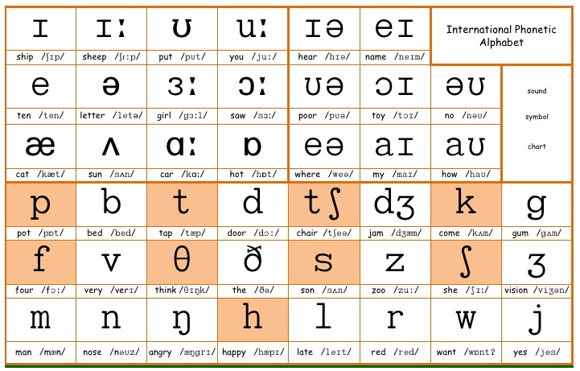

|  |  |
| --- | --- |
| Main Word | IPA Transcriptions |
| Sandwich | /ˈsæn(d)wɪtʃ/ |
| Executive | /ɪɡˈzekjətɪv/ |
| Comfortable | /ˈkʌmftəbl/ |
| Jewellery | /ˈdʒuːəlri/ |

**Pauses and Stressing:**

Speakers give pause between the parts of a statement, usually the long and complex ones to maximize the meaning carried by their statements. On the other hand, stressing means to focus and pressurize on a particular word/ phrase/ clause in a statement with using extra muscular energy that might affects the meaning of the statement(s).

Example: (Pauses)

Could you tell me when I can meet you at your city office?

Could you tell / me when I / can meet you / at your city office?

Could you tell me / when I can meet you / at your city office?

Example: (Stressing)

1. **I** want you to leave now. ( Essentializes the speaker)
2. I **want** you to leave now. (desire of the speaker)
3. I want **you** to leave now. (desire of the speaker to a particular one)
4. I want you to **leave** now.(desire of the speaker to a particular action)
5. I want you to leave **now**. (desire of the speaker to a particular occasion)

**Fluency:**

Fluency denotes the moderate pace of your delivery. Never be so quick, nor be slow.

**Proper Use of Non-verbal Cues:**

Maintaining *Gesture, Posture, Appearances, Eye-contact*, and *Facial Expressions*

**Engaging Audiences:**

Ensure audience-centered approach by anticipating their passions and interests. Craft your technical tools to manage your sessions with concentration grabbers.

**Speak as You Need:**

Speak clearly, completely, concretely, and concisely to meet your purpose.